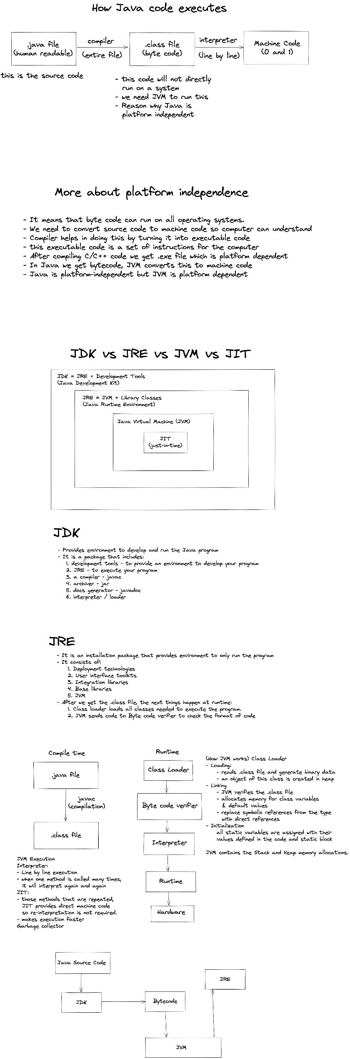

* Java source code is the code you write,
* goes into the JDK and
* JDK then compiles it, there is javac compiles it and convert it into bytecode i.e., .class file
* Byte code runs into JVM
* JVM converts it into executable code, that we run into JRE and we get the output like Hello World! /Game playing/ app
* JVM & JRE not having compilers only JDK having compiler.

**JRE vs JVM**

-JRE is the box and JVM is the actual content inside the box

-whatever work JVM is doing, its doing with the help of JRE. Whatever the files and libraries that JVM need JRE will provide it.